Discussion fall 2018

Luzuk Guru education account:

Password: Diony0131#

[[ aline.jeanlouismaxi@supersites.onmicrosoft.com

password: Aline0612

]]

Setting Bitnami application password to 'ol9gczUCXFIm'

Server administrator username(servername) alineapp

Password: Diony@app0131$

PhpMyAdmin account { user:aline

Password: dbconnect01# }

User:John

Pasw: &sasou%02#

mysql -u John -p < AWBackup.sql

* <http://localhost:8888/phpmyadmin>

…………………………………………………………………………………………………………………………………

As a nurse how to diversity potfollio: healthcare,investment,financially.

Marietherealtor.com{ websitebox: login:@marietherealtor.com, password: Andrew10!

………………………………………………………………………………………………………………………………………….

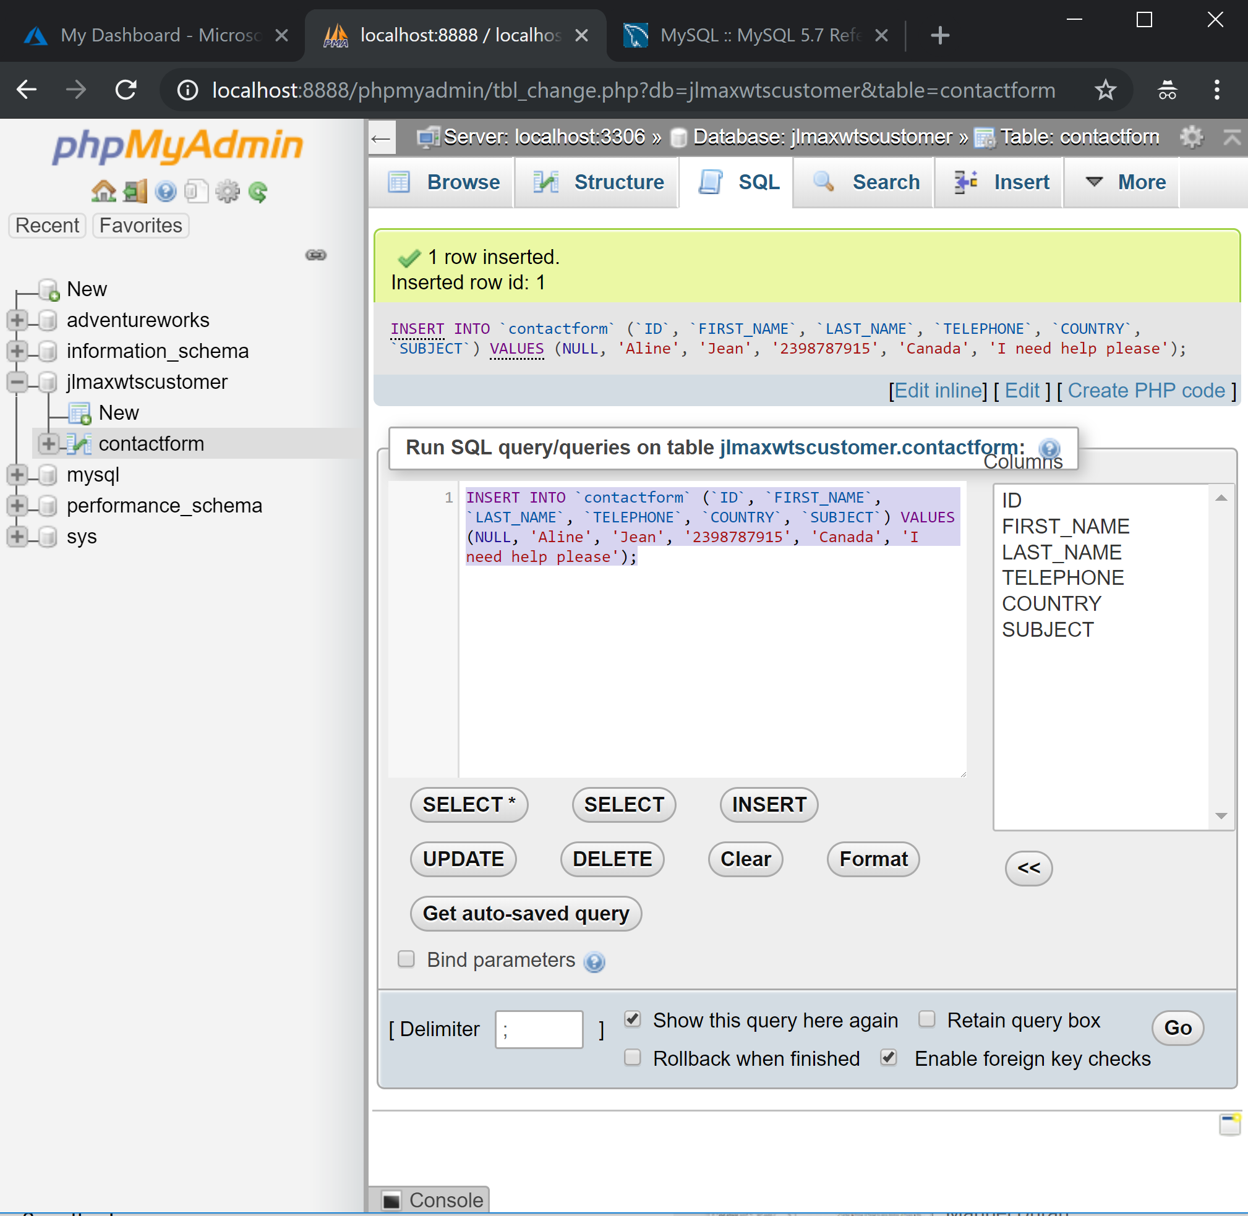

……………………….Hi Thim,

This is Aline from Rasmussen college

Thank you for your respone, I really appreciate that

Actually I’m almost done. My biggest issue right now for some reasons, I cannot connect to any server by using FileZilla. Below is my screenshot.

Can you please take a look at it to see if something is missing?

Thank you!

…………………………………………………………………………………………………………………………………………

693799==ticket nb

18552004146=vital source==password:Diony0131#

Github:Sasou0612#

Module01 discussion:

Best Practices and mobile-friendly design are important considerations when beginning the design of web application.

**First Post**  
Research and explain at least 3 best practices when it comes to **designing web application**. Also, select one best practice and find a website that does not meet this standard. Provide the URL and explain the issues related with design. Also, provide links to any references used in your research.

**Reply Post**  
Respond to a classmate's post regarding the best practice that wasn't employed by the website they choose. What other best practice did the website also miss?

……..

Answer: when designing a web application, a couple things need to be considered. First of all, you should know what you want to accomplish and validate your idea before getting further into development. Every web application has a main dashboard that provides maximum functionality to the user. When designing a web application; it is recommended to choose the light color for the header and maintain consistency in color selection for text, buttons, cards etc. having unnecessary design elements to your website will make it harder for visitors to accomplish what they're trying to accomplish. That’s why the layout should be simple and consistent. One more thing is using elements like breadcrumbs or form steps will help eliminate unnecessary clicks and show hierarchy.

I feel like I was probably make a mistake somewher; so today I started everything from the beginning. I created new storage account and virtual machine. Then I run across on something different. How?

After creating the tunnel settings in putty; I logged in to phpMyAdmin so I can manipulate the MySql DBMS. Then I created a custom mysql DBMS user name “John” with all priviledges at this point every thing was perfect. However when it comes to restore the Adventureworks database where I had to use the unzip file and replace the DBMSUsername which is “John” like this ”mysql -u John -p < AWBackup.sql ”; I received an error 1050 message:



Can you please help me out?

Thank you!

Aline

Hi my fellow students,

I just selected some names that I saw on the general questions forum. I know that I’m not supposed to message you in private you’re probably busy or something ; but I feel like I’m totally destroyed and lost because I can’t find help to finish my assignment. I’ve been staying at home today spending all day long struggling to do my homework. Unfortunately, I can’t. Please, guys what did you do?

I talked to the advisor to either remove the course or have another instructor. Please let know What you do.

Aline Jean louis maxi

…………………………………….

Response:

That’s true I’ve seen a lot of website which contain certain color palette where it’s very difficult for users to read. It’s recommended that a good web design should avoid mix color palette with plenty conflicting color. According to my research; the navigation must be eye-catching and should often be at the top of the page. This site below it’s an example of unpleasant color scheme site.

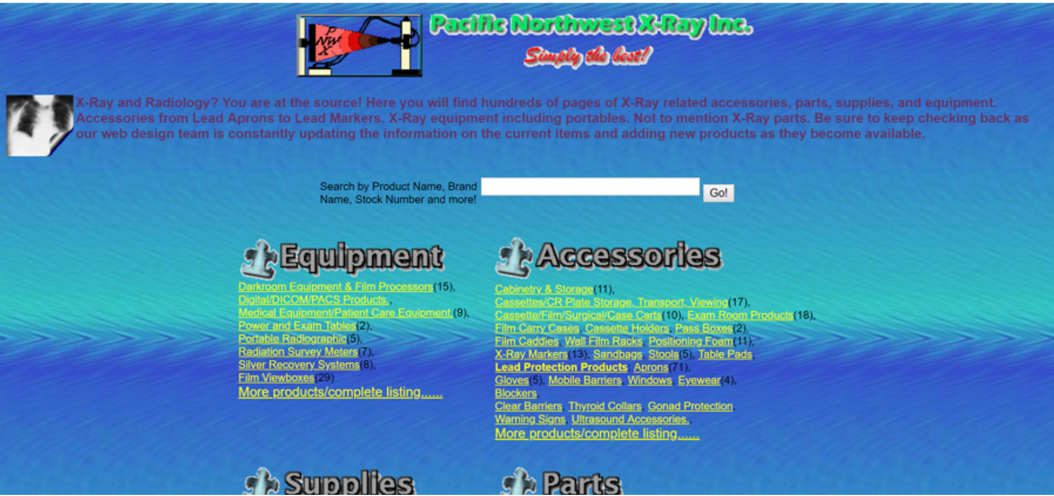

Hi professor,

I have encountered a lot of difficulties restoring the adventureWorks database and I’m still waiting on your help to finish it. I’m so sorry I’m out of time; there’s no way I will be able to submit my assignment tonight. can you please tell what time are you available for tomorrow? so I can call you because I’m still stuck.

Thank you!

Aline

Hi professor,

Thank you for your response.

Unfortunately, I could not get through it. To me I did everything according to the document that Rasmussen College provided; but you know that’s technology. It seems something went wrong it did not work well. Please, is there a way you can make a quick video about the set up(configure the development environnment)?

Hi Nick,

One more time I feel very disappointed with this course. It’s seems like the professor doesn’t want to help at all. He ‘s making students to figure out things themselves. I’m getting stuck in the first week assignment to restore the AdventureWorks Database. I ‘ve sent three messages for more than 48 hours and no answer until this moment. I’ve checked on the discussions forum and I’ve noticed lots of students struggling to find answer for their issues. In the live lecture, he did not elaborate on the topic. That’s very discouraging; I want either to drop this course or have another professor who can guide me with technology. I will call you tomorrow for more details.

Thank you!

Aline

Hi Nick,

Thank for your response.

I don’t mind taking this CIS3801C course for now; my big problem is because my instructor is not available to help. So, may I please another professor?

I think I’m not the only one student who call for assistance. Like I said before I visited the discussion forum for general questions. Almost every student got stuck and asked for help. I’m very frustrated.

Please I really need your help.

Thank you.

………………………………………………………………………………………………….

Module 02 discussion:

Research and summarize at least 3 best practices when it comes to **web application development and target audience**. Then, consider the local business you selected for your course project. Describe its target audience.

Answer:

Nowadays people on the planet mostly use the internet or email on their smartphones. When it comes to web application, developers need to focus on the device’s compatibility. It means whether the user is accessing the site on a mobile phone, tablet or a desktop computer; the app should available on all devices. However, it is best to figure out who you are targeting for your web development. This way you can have a solid understanding of your target audience and of course know how many different platforms the application must be available on. Developing a web application is a feature rich product, we have a lot of decisions to make such as: choose programming language, framework, server, database, etc. It is important to select the right technology based on research and experience.

I’m going to create a website for my local business. That’s what I intend to do after my graduation as a computer scientist. The target audience will be everyone or other business around me who looking for help related to technology. I will provide users with online services such as: IT management, web design, web development, custom site design, site repair and maintenance, cloud services and etc. The name will be JLMax web-tech services (I already had the domain name: jlmaxwts.com). On the website users will be able to make a payment, request a ticket, chat with personal support, etc.

<select there are numerous web app development best practices to consider,< app is instantly available on all devices, whether they are desktops, laptops, mobile phones or tablets.>

No one would be happy to spend his time on a website where information (resources) is difficult to find. Planning a website with the target audience in mind offer the best balance of creativeness and allow users to find items in one click. One of the best practices is when developing a webpage is to have a user-friendly website to make people visit your page again and again. That way your page can be one among the best ones on the market.

Good point

Since more people access the internet with their mobile devices than from a desktop; responsive Web design is an essential tool for anyone with a digital presence. When developing a web application, it is good for the designers to create web pages that can respond differently based on the device the viewer sees it in.



Figure 1mmm

Figure 2

,,,,,,,,,,,,,,,,,,,,,,,,,,,,,,,,,,,,,,,,,,,,,,,,,,

Module 03 discussion

In your post, research and describe at least 3 best practices of **responsive design**.

Three best practices of responding design are:

**Minimize and mobilize:** Nowadays more people access the internet with their mobile devices. Responsive web design means that developers have to develop a web application that can fit on three screens: mobile, tablet and laptop or desktop. So, it is recommended that you consider the mobile version of your site as its own stand-alone website. Mobile first approach focuses on small screen to ensure only essential content is concentrated on.

**Managing content**: Hide some content that mobile users don’t really interest on. Pull the most important things to mobile users to the top. That way, they’ll have likely seen the most important thing you are trying to show or tell them.

**Breakpoints**: According to my research; when talking about ‘responsive’ designs, the focus should ideally be on adaptability and flexibility of designs which are possible only when breakpoints are built around the content.

Reference:

Uzra, M. (2018, May 10). Best Practices for Responsive Web Design 2018. Retrieved from <http://www.techmagnate.com/blog/6-best-practices-of-responsive-web-design/>

Response:

Creating a web application that works well across different device types is a smart idea for developers. Even though most people use mobile devices, but you never know your audiences probably use desktop or laptop computer instead.

……………………………………………………..

Think you Jason for enlighten there. I really like your thoughts about prioritizing content. Content is the key aspect of any web site, we have to identify it and create a page structure according to that content. This way when users access to that page it would be easy for them to find what they need.

……………………………………………………………

**Competency course**

Module 02

After attending the live lecture; I have a lot of understanding of visual communication. Especially; how to evaluate and utilize cognitive visual communication to send perceptual messages. As a web developer; I would like to see more reflexion(use example based on computer science) on how  I can benefit from this competency to create my web application.

Thank you.

this competency can connect to others; like every time a student passes a competency; he/she should post to encourage others to do the same. Because some students are really scared to learn this way but to me is perfect to have a course at your own pace.

Module 03

Symbol is very important when it comes to visual communication. I learn how you can send a message by using logo, and symbol. I also learn then emotional effects of logo, logo experience association. For I don’t really have a big question. Every thing makes sense to me.

………………………………………………….

Module 04 discussion:

When it comes to web design, it is very important to have a deep understanding of your target audience, their needs, abilities, and limitations. You should always strive to improve the quality of the user’s interaction with your website.

**First Post**  
In your post, research and describe at least 3 specific areas related to building the **user experience**.

**Reply Post**  
In your reply post, select one specific area from a classmate’s post. Locate a site that you’ve browsed online that you feel does a poor job in this area when it comes to user experience. Explain at least 2 reasons why the website does not appear to follow this best practice.

…………………………

make your website to attract as many visitors as possible is a great thing when it comes to build user experience. Once you know your target audience, their needs, abilities, and limitations; you can apply some specific best practice to make your site welcoming to all visitors. For instance; you can make your site accessible to the users by making navigation menu more straightforward as it lets users skip directly to specific content. to interact with your website visitors, acquire new customers, as a developer you should start with your content including videos and images in your blogs post.

I have visited a lot of website that ask me for live chart. Some times I close the button right away to me at certain point it bothers me. So, one day I had a problem with my credit card while I was doing a transaction online . I suddenly found a button says “start chatting now” at the corner left on top of the page. I clicked on it and I immediately found someone who helped me. That day I realized how helpful it is to put live chat on the website. I now consider that like one of the best practice when it comes to user interaction. Believe it or not, your website visitors’ experience increases exponentially when they can quickly get their questions answered via chat instead of calling in and waiting on hold to speak to a customer service representative.

Another specific areas related to building the user experience is : Turn off autoplay on videos on your website. Instead If you have an important video for the users, let them decide when to play the amazing video you have on your website.